**What is Functional Programming ?**

It is a way of programming where we just focus on **WHAT** not on **HOW**.

It is a form of Declarative Programming.

Before deep dive into Functional Programming in java, I want you to solve the below problem :

* Find out the odd numbers in the given list.

If you can observe that in the above solution, we are getting the expected output. But this solution will come inside **Imperative Programming.**

Because, in the above problem our business logic is to find out the odd number. So we know, to implement this we have to iterate over the list and then we need a Odd number condition. Iterating the list is not our business logic, then why we need to explicitly write the iteration logic. Also, the if block we are providing over there should also be drop because the concern part is the condition only.

Now the conclusion is, writing **for** and **if** syntax should be the responsibility of programming the only part who belong to business logic is the condition we provides in the **if** block.

The above same program is written down below with functional programming.

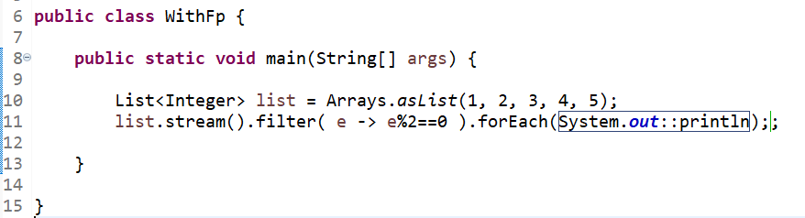

Using functional programming, our code looks more readable and compact. For now, don’t worry the syntax. Just compare the length of both the code.